16-Bit Subraction

Progarm:-

LDA 2021

MOV B,A

LDA 2022

ADD B

STA 2023

LDA 2024

MOV B,A

LDA 2025

ADD B

STA 2026

Output:-

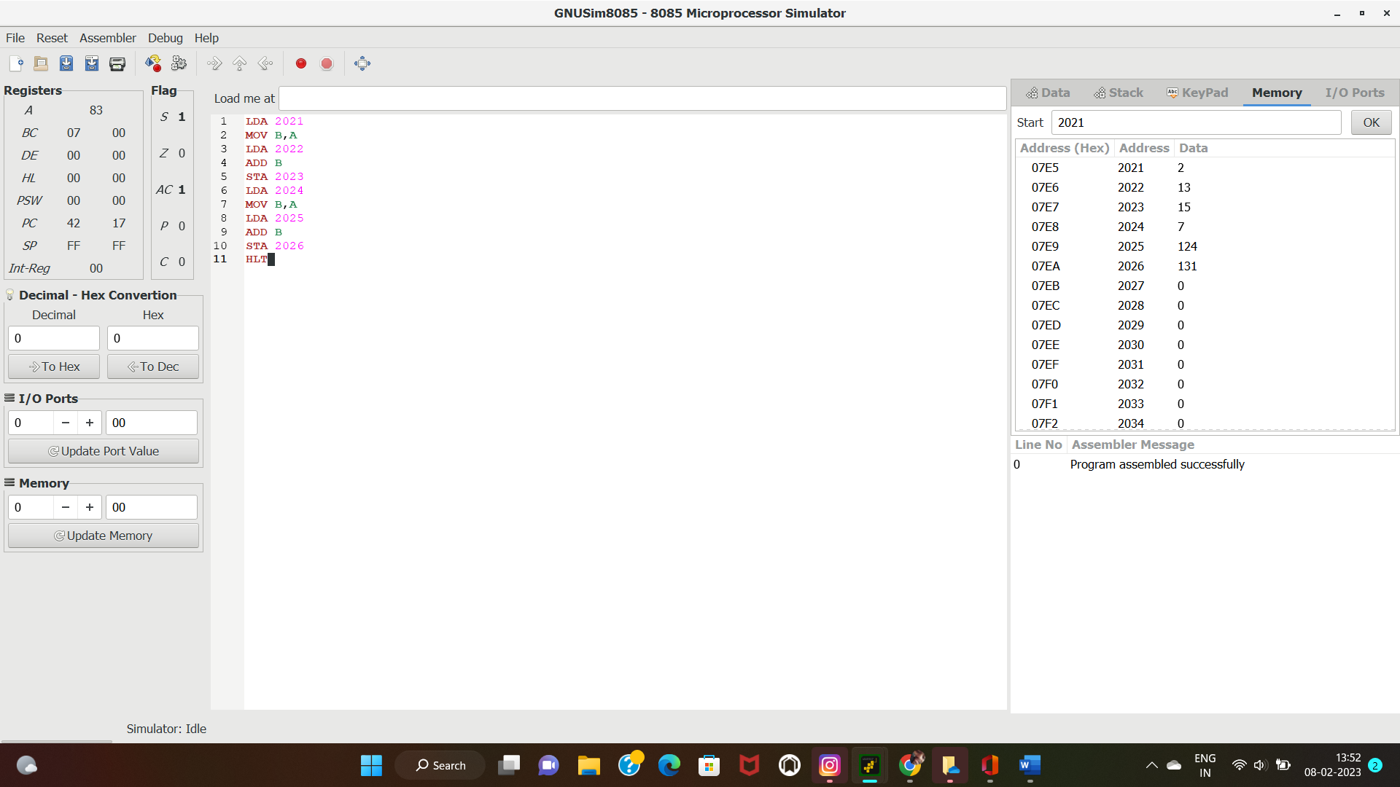

HLT